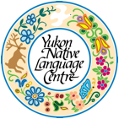
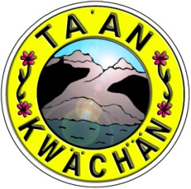

Do you want to learn your language?

Ta’an Kwach’an Council (TKC) and the Yukon Native Language Centre (YNLC) are partnering to offer a language training program in Southern Tutchone (Ta’an Dialect)

Orientation and Training for the Mentor Apprentice Program (MAP)
(One-to-One or Small Group Language Immersion)

March 12, 13 and 14, 2018
9:00 a.m. to 3:00 p.m.

Yukon Native Language Centre, Yukon College

In this session, you will learn more about the mentor-apprentice program model (MAP), an intensive language learning approach and learn how to make audio and/or video recordings. Mentors and potential apprentices will work on their language learning plan. Following this, language apprentices are required to complete a minimum of 100 hours of language immersion/practice/study over a 10-week period and complete weekly language learning logs.

The objectives of MAP are for students to:

a) improve speaking and listening skills in the language through practise with an elder/speaker
b) record the vocabulary and language structures they are exposed to throughout their sessions with the speaker, and
c) have increased confidence in communicating in the language.

Who should attend:

Anyone who is interested in learning the language and thinks this approach might work for them. Funding provided for TKC citizens only.

Registration:

Please complete that attached application form and submit (by March 7th) to:

Name: Lynn Sparks or Roberta Behn
Phone: 867-668-3613 x 401, 867-668-3613 x 403
E-mail lsparks@taan.ca, rbehn@taan.ca

Application Information:

Please fill out all the information below and return in person to the Ta’an Kwach’an Council (TKC) office or by mail or email to:

Name: Lynn Sparks or Roberta Behn
E-mail lsparks@taan.ca, rbehn@taan.ca

For further information, phone Lynn or Roberta at: 867-668-3613 x 401 or 867-668-3613 x 403. Application form is due by Wednesday, March 7, 2018. People who have been selected will be contacted by Friday, March 9, 2018 to confirm arrangements.

Application Form:

Name: | Phone:
Address:

Email:

Are you a TKC Citizen? Yes/No (please circle)

Please explain why you want to learn Southern Tutchone (Ta’an Dialect)?

What work have you done that contributes to reviving and strengthening the Southern Tutchone language?

How many hours each week will you commit to learning the language?
*Note that the program is 10 weeks plus a 3 day orientation/training and an oral interview

