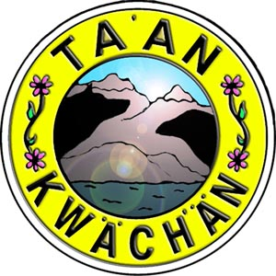
Elders Council Meeting at 09:30 AM on February 6th, 2018 in the TKC Health Board Room

