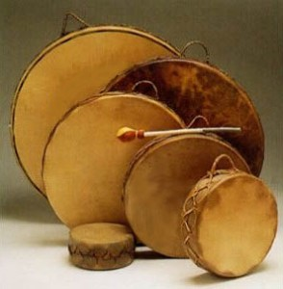
TKC Youth Council will be hosting a drum-making workshop for all TKC Youth
We have 4 open spots if you are interested!

~Open to all TKC Youth Ages 12-29~
Call Tiffany at 334-2640 if you want to add your name to a list.

Date: Saturday September 26, 2015
Time: 9:00 am-3:00 pm
You MUST register if you want to come!
teckert-maret@taan.ca
Lunch and Snacks will be provided – Rides can be arranged!
~

