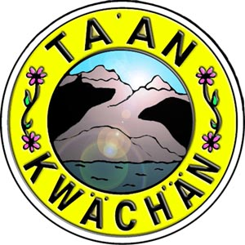
Chief & Council Meeting at 17:30 PM on February 6th, 2018 in the TKC Board Room

