**Plant Medicine**

[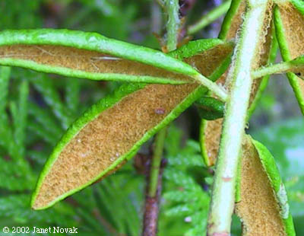](https://thewellesleybog.wordpress.com/2011/11/28/labrador-tea-ledum-groenlandicum/)[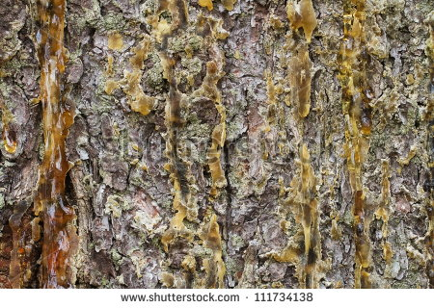](http://www.google.ca/url?sa=i&rct=j&q=&esrc=s&source=images&cd=&cad=rja&uact=8&ved=0CAcQjRxqFQoTCJLQv5Kgs8cCFQsQkgodA5MAwg&url=http://www.shutterstock.com/similar-59260099/stock-photo-close-up-of-a-spruce-bark.html&ei=CHjTVZKsH4ugyASDpoKQDA&bvm=bv.99804247,d.aWw&psig=AFQjCNEc2wFU-SWG-dkIAWGgx_AktjVYMA&ust=1440008567197826) **Workshop**

Monday August 24, 2015

[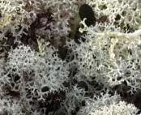](http://www.google.ca/url?sa=i&rct=j&q=&esrc=s&source=images&cd=&cad=rja&uact=8&ved=0CAcQjRxqFQoTCJjg0vChs8cCFYgNkgod0SUEWg&url=http://www.wrrb.ca/content/boreal-caribou-t%C3%B4dz%C4%B1-habitat-and-habitat-use-study-0&ei=2nnTVZiLGIibyATRy5DQBQ&bvm=bv.99804247,d.aWw&psig=AFQjCNGKHK7Hfzzs78QP3Yw13y6H3UzhIQ&ust=1440009027346107)[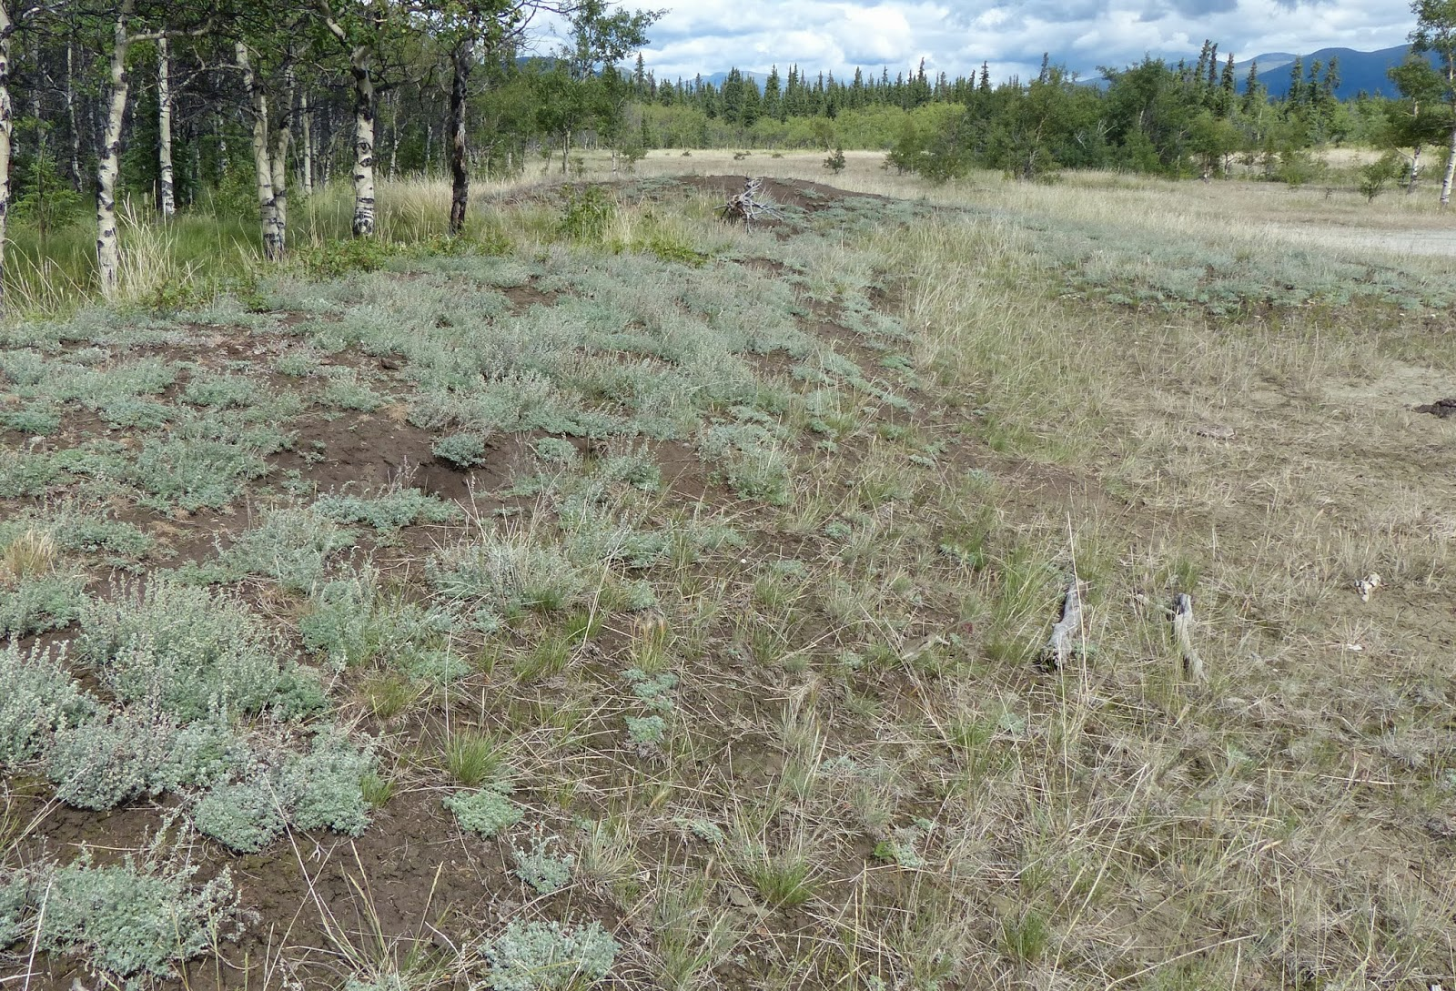](http://www.google.ca/url?sa=i&rct=j&q=&esrc=s&source=images&cd=&cad=rja&uact=8&ved=0CAcQjRxqFQoTCLC53tqfs8cCFUIWkgod9pMCGA&url=http://yukonwildflowers.blogspot.com/2013/09/artemisia-frigida.html&ei=k3fTVfCjI8KsyAT2p4rAAQ&bvm=bv.99804247,d.aWw&psig=AFQjCNEu9mS2V9eQuvkIaBadVstwcBvQUA&ust=1440008463262657)Health Board Room

9am – 4pm

Facilitator: Laura Nolan

Laura is a Ta’an citizen currently studying at the Pacific Rim College in Victoria

For phytotherapy (medical herbalist)

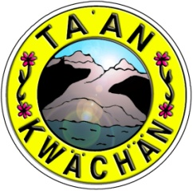[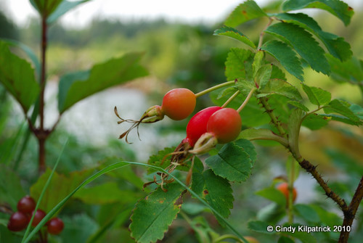](https://www.google.ca/url?sa=i&rct=j&q=&esrc=s&source=images&cd=&cad=rja&uact=8&ved=0CAcQjRxqFQoTCKzFvMihs8cCFUYUkgodPfIMGQ&url=https://natureofthehills.wordpress.com/tag/prickly-rose/&ei=hnnTVazqCMaoyAS95LPIAQ&bvm=bv.99804247,d.aWw&psig=AFQjCNFhFL65JBTkXR119OrOahZ3GorqMg&ust=1440008946608455)